1] ovn-sbctl set chassis testserver external-ids:enable-chassis-gw=true

2]

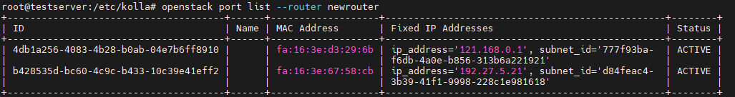

* ovn-nbctl set logical-switch-port 4db1a256-4083-4b28-b0ab-04e7b6ff8910 external_ids:"neutron_bgpvpn\:vni"=1001
* ovn-nbctl set logical-switch-port b428535d-bc60-4c9c-b433-10c39e41eff2 external_ids:"neutron_bgpvpn\:vni"=1001

3] 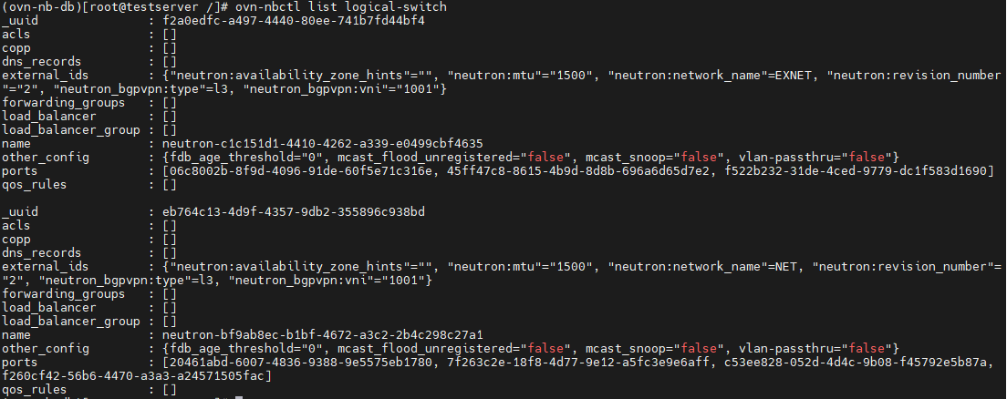

* ovn-nbctl set logical-switch neutron-c1c151d1-4410-4262-a339-e0499cbf4635 external_ids:"neutron_bgpvpn\:type"="l3"
* ovn-nbctl set logical-switch neutron-c1c151d1-4410-4262-a339-e0499cbf4635 external_ids:"neutron_bgpvpn\:vni"="1001"

* ovn-nbctl set logical-switch neutron-bf9ab8ec-b1bf-4672-a3c2-2b4c298c27a1 external_ids:"neutron_bgpvpn\:type"="l3"
* ovn-nbctl set logical-switch neutron-bf9ab8ec-b1bf-4672-a3c2-2b4c298c27a1 external_ids:"neutron_bgpvpn\:vni"="1001"

4] ovn-sbctl set chassis testserver external-ids:enable-chassis-gw=true