1] Below result has VM IP 121.168.0.202

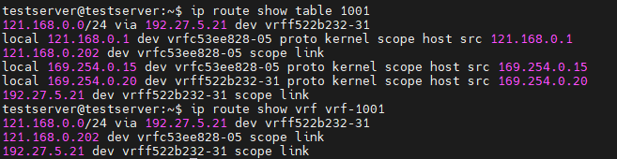

2] VM IP is not visible in the below result.

